**High Performance Computing**

**System Administrator**



**CENTRE FOR DEVELOPMENT OF ADVANCED COMPUTING PUNE**

**CASE STUDY**

**Submitted By:**

Batch September 2022-23

**AIM**

Build a two node Disk-less HPC-Cluster using OpenHPC with warewulf, slurm, Nagios and do a HPL benchmark and document the result.

|  |  |  |
| --- | --- | --- |
| **S No.** | **NAME** | **PRN** |
| **01** | **Lalit Painkra** | **220940127042** |
| **02** | **Langde Dhammdip Govindrao** | **220940127043** |
| **03** | **Mahendra Kumar Pankaj** | **220940127044** |
| **04** | **Megha Chayrulal Kalyankar** | **220940127046** |
| **05** | **Numesh Kumar Sahare** | **220940127047** |

**Group Members:**

**TABLE OF CONTENT**

**Requirements ……………………………………………………….04**

**Hardware reqirements……………………………………….**

**Software reqirements………………………………………...**

**Installation …………………………………………………………..05**

**Pre-Configuration ..…………………………………………………06**

**OpenHPC with Warewulf…………………………………………..08**

**Slurm ..………………………………………………………………12**

**Nagios ………………………………………………………………..15**

**Ganglia ……………………………………………………………...21**

**HPL Benchmarking ………………………………………………...23**

**Commands History.............................................................................29**

**REQUIREMENTS**

**Hardware reqirements:**

* RAM : 32 GB
* PROCESSOR : i7 10 gen
* HDD : 200GB

**Software reqirements:**

* Vmware workstation
* Centos 7 iso

*Internet connectivity **INSTALLATION**

The head node is configured as the primary node in the cluster and is setup to manage and install all compute nodes.

Create new virtual machine and BootfromtheCentOS*installmedia(DVD).

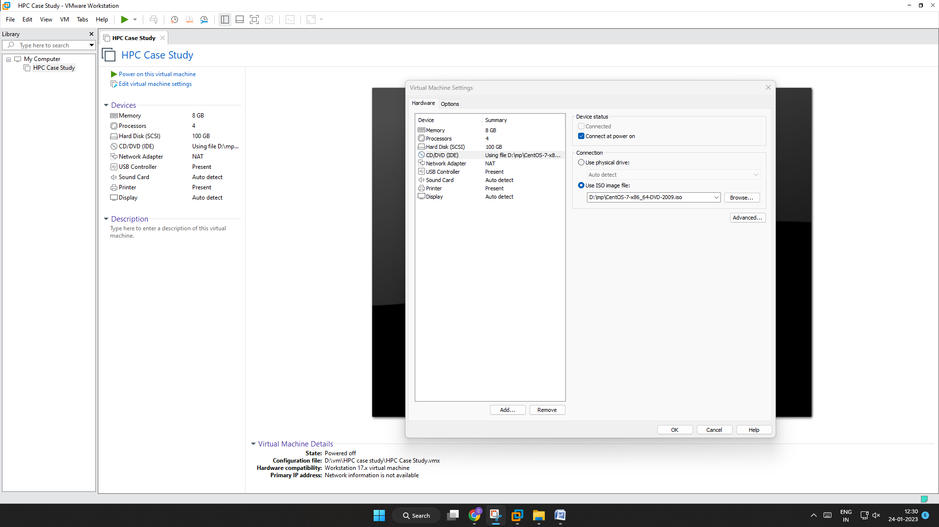

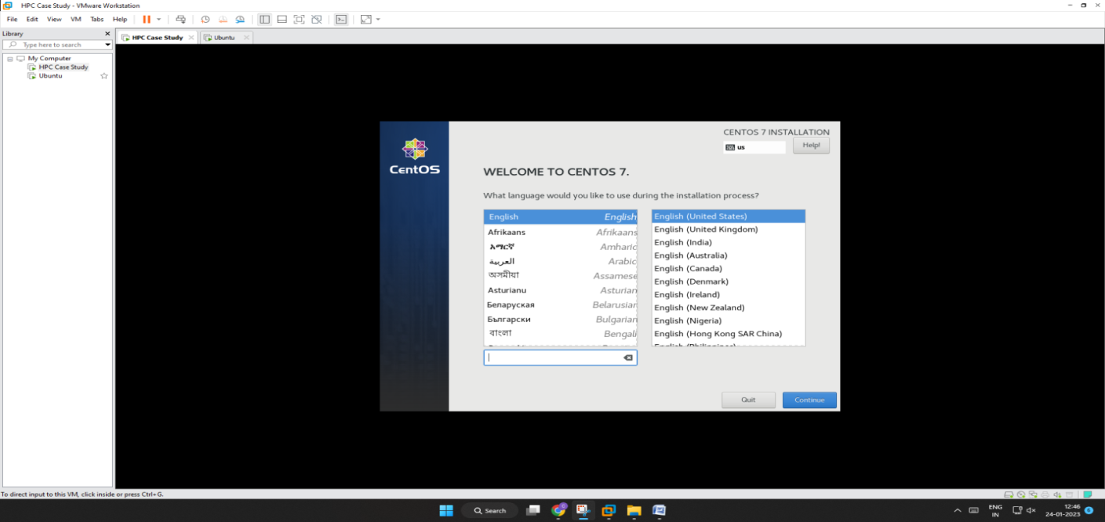



After done to create virtual machine of Centos 7 with master configuration few must configuration are required

1. Setting hostname : master
2. Firewalld must be disabled
3. Selinux disable
4. Network configuration must be done

# hostnamectl set-hostname master

[root@master ~]#

# systemctl stop firewalld

#systemctl disable firewalld

# vi /etc/selinux/conf

🡪 Change enforcing to disabled

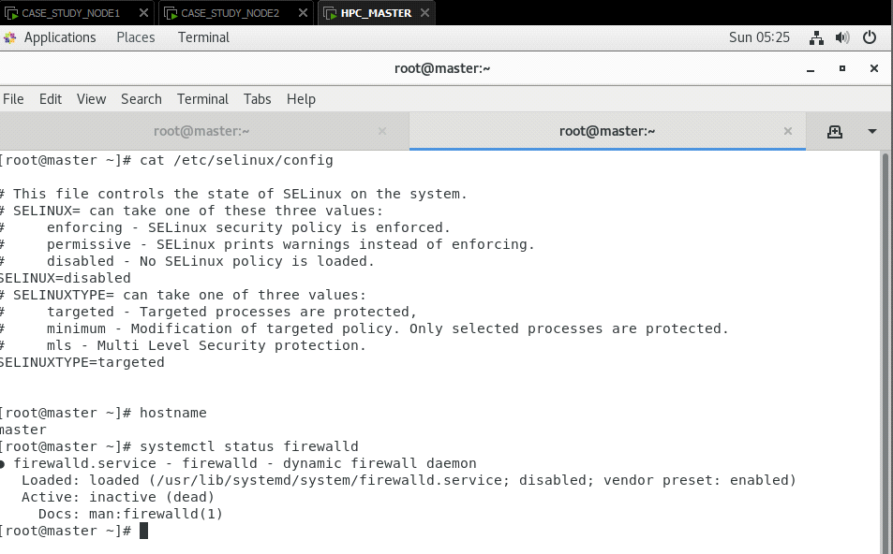

# dhclient -v

# ip a

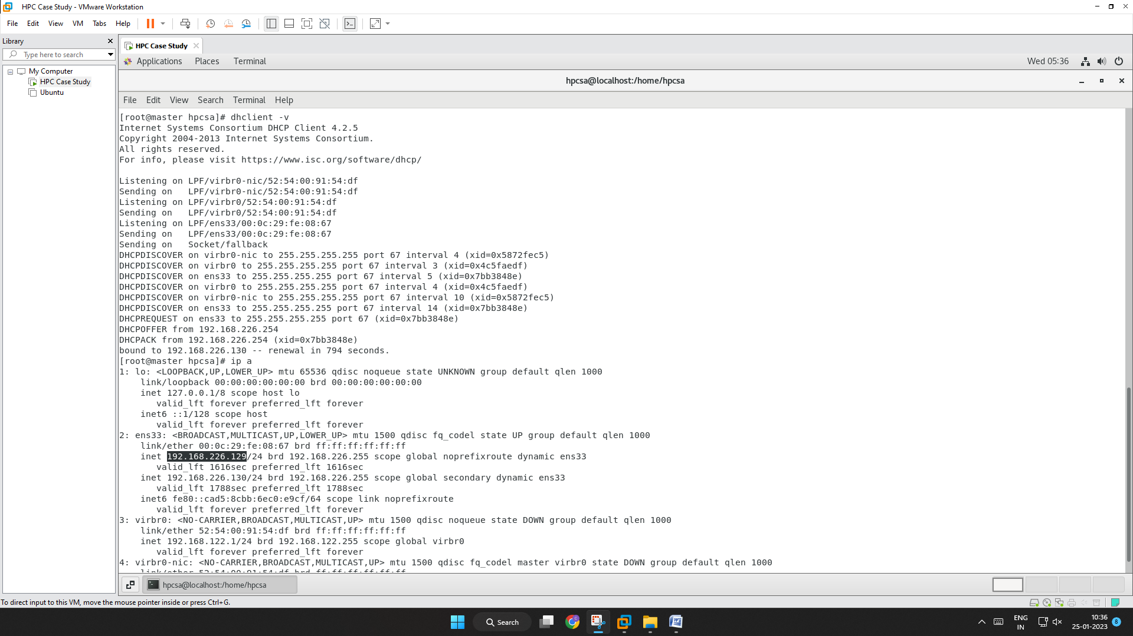

# nmcli -p connection show --active

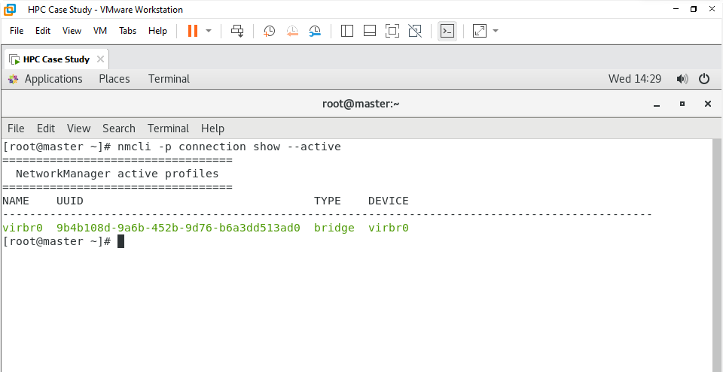

**openHPC with Warewulf**

**OpenHPC** is a set of community-driven FOSS tools for Linux based HPC. OpenHPC does not have specific hardware requirements.

Warewulf is **a bare metal, stateless, cluster provisioning solution to facilitate the operating system deployment and management of large quantities of clustered hardware resources**. Extensible. Easy to change the default functionality, node images, and customize for any clustering use-case**.**

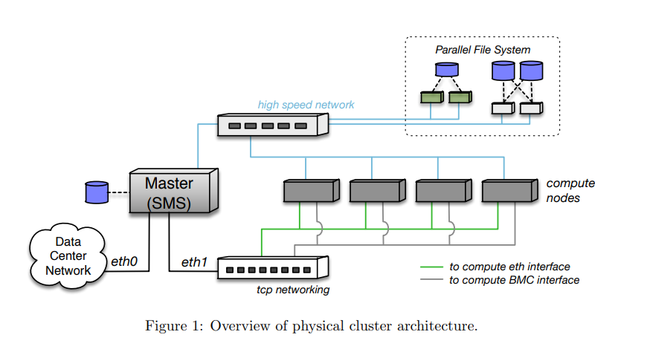

#Yum install http://build.openhpc.community/OpenHPC:/1.3/CentOS_7/aarch64/ohpc-release-1.3-1.el7.aarch64.rpm

# yum -y install ohpc-base

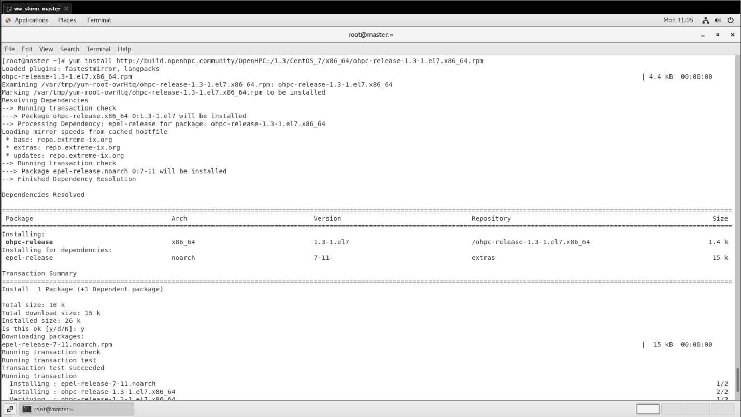

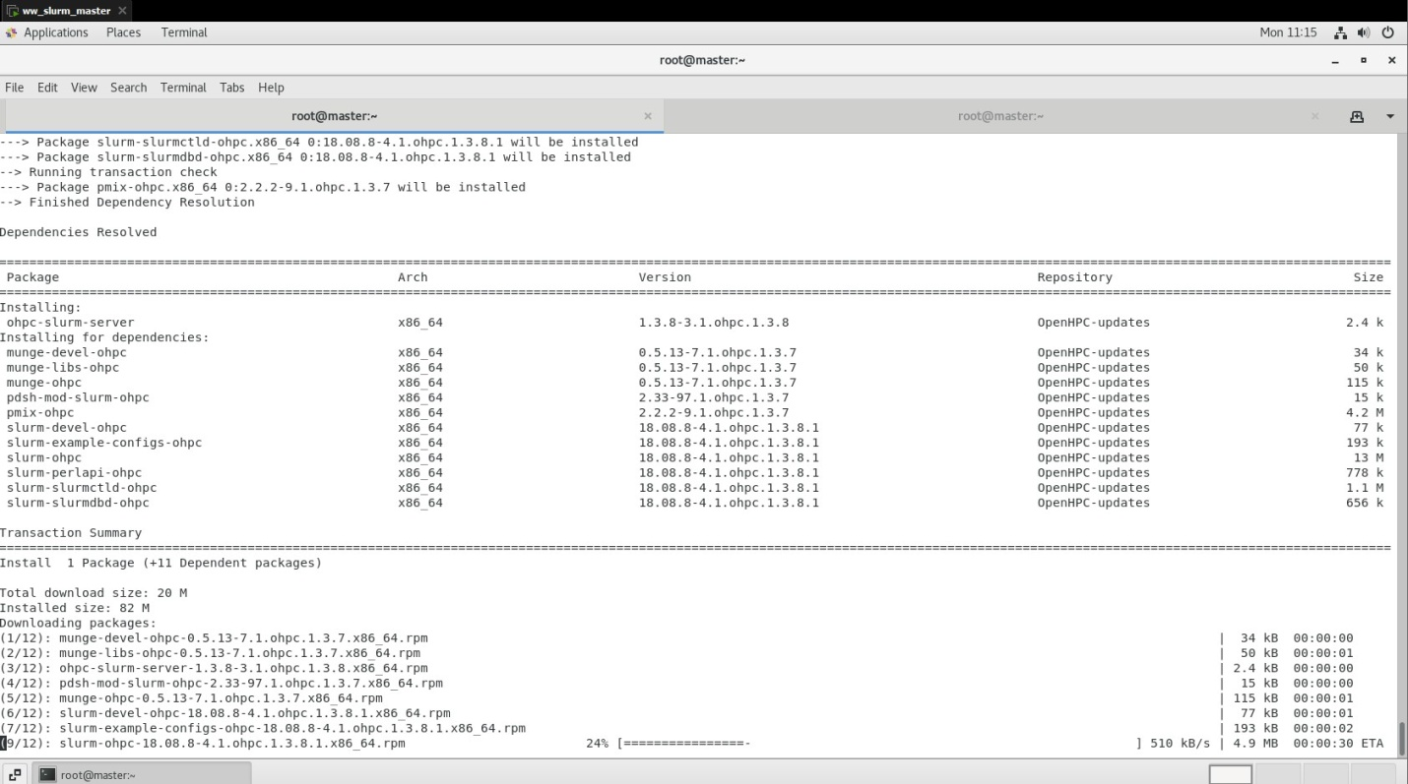

# wwinit database

# wwinit ssh_keys

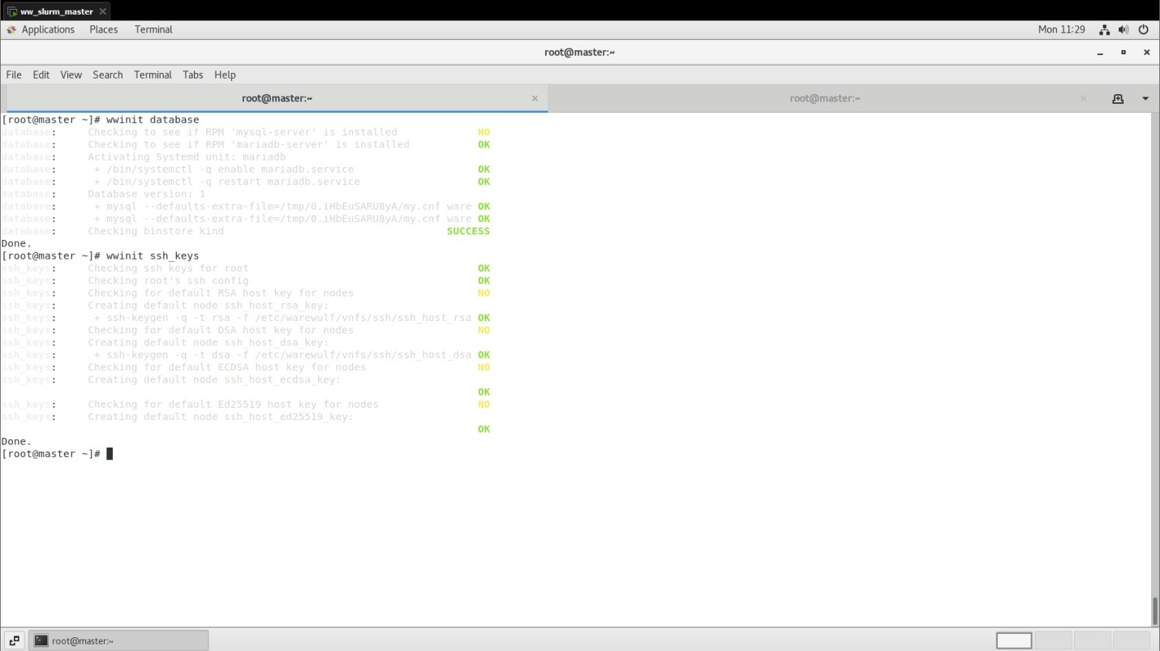

# df -hT | grep -v tmpfs

# echo "master:/home /home nfs nfsvers=3,nodev,nosuid 0 0" >> $CHROOT/etc/fstab

# echo "master:/opt/ohpc/pub /opt/ohpc/pub nfs nfsvers=3,nodev 0 0" >> $CHROOT/etc/fstab

# cat ${CHROOT}/etc/fstab

# cat /etc/exports

# echo "/home *(rw,no_subtree_check,fsid=10,no_root_squash)" >> /etc/exports

# echo "/opt/ohpc/pub *(ro,no_subtree_check,fsid=11)" >> /etc/exports

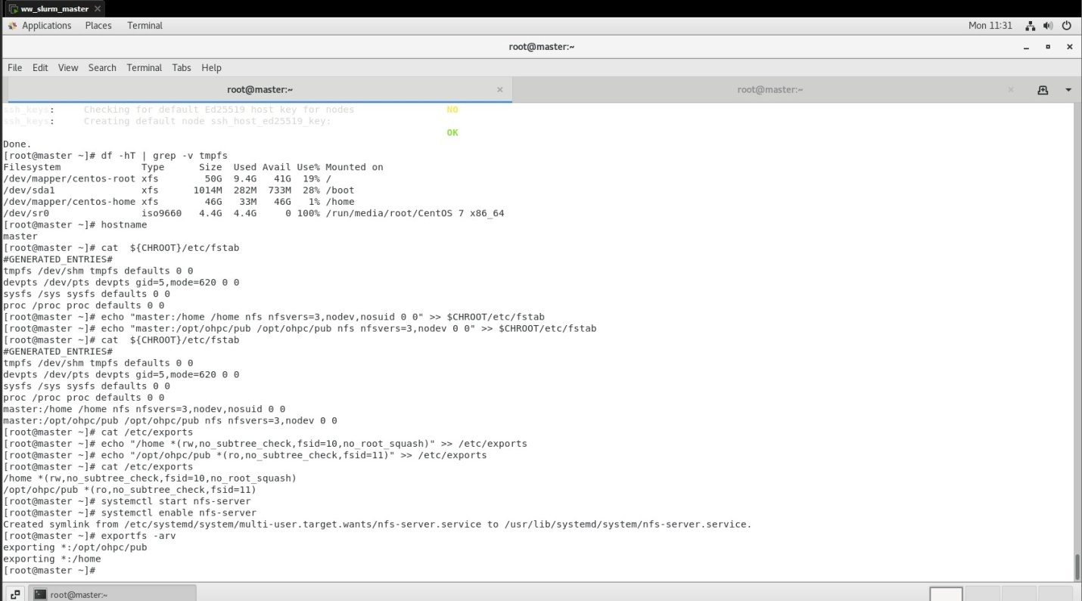

# systemctl start nfs-server

# systemctl enable nfs-server

Booting Disk-less Node

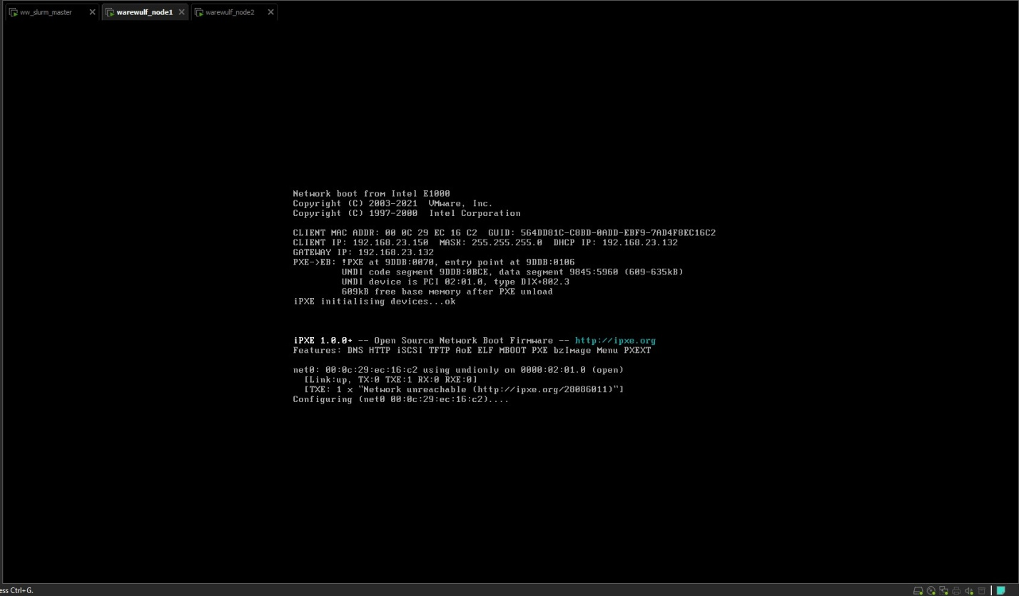

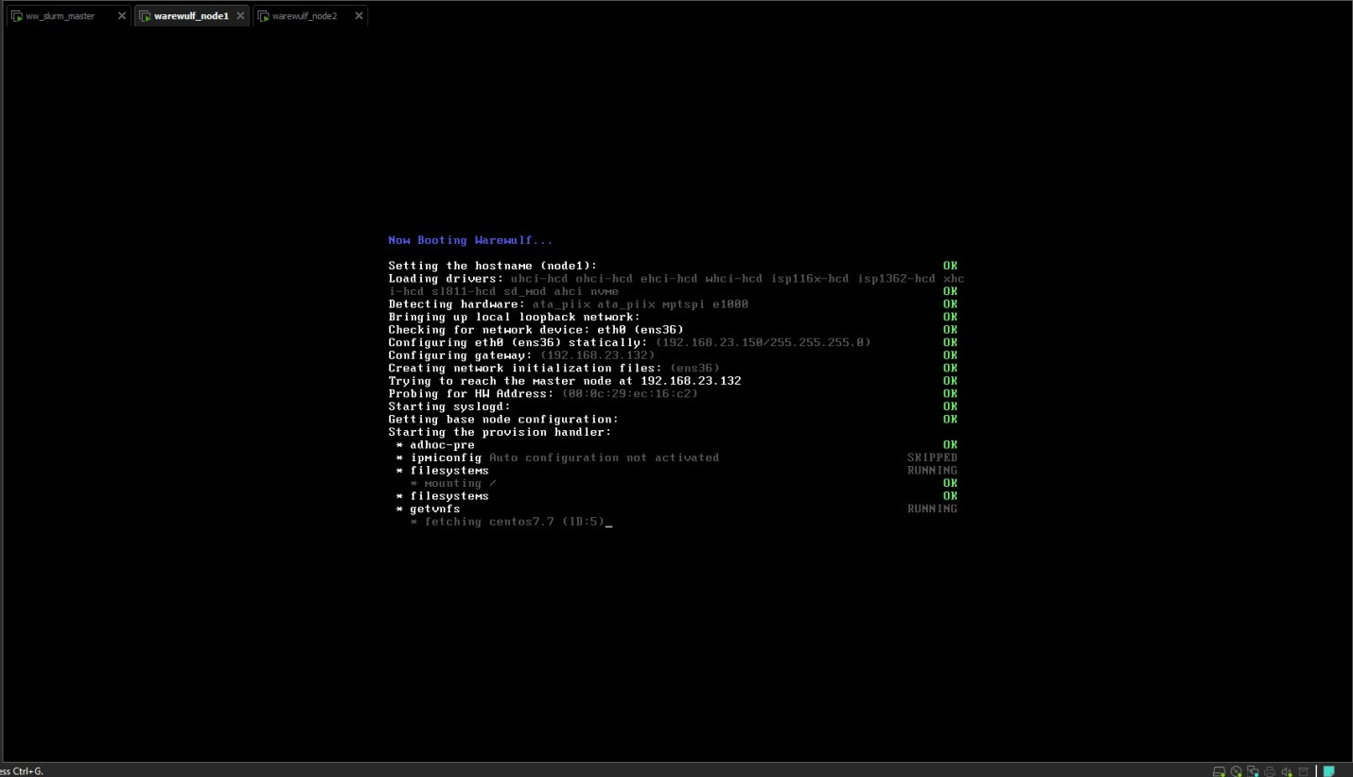

# ip a (Booted node)

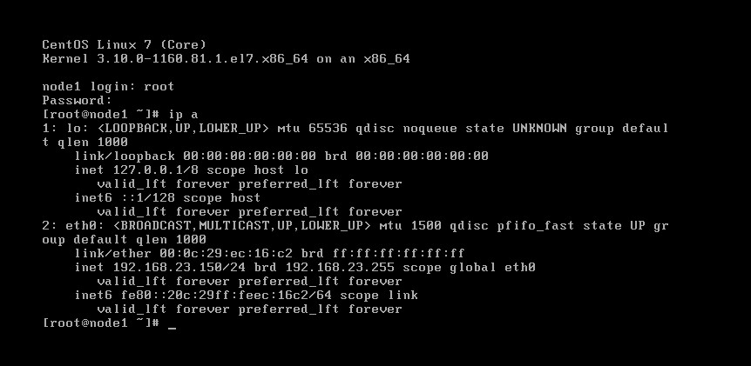

**SLURM**

The Slurm Workload Manager, formerly known as Simple Linux Utility for Resource Management (SLURM), or simply Slurm, is a free and open-source job scheduler for Linux and Unix-like kernels, used by many of the world's supercomputers and computer clusters.

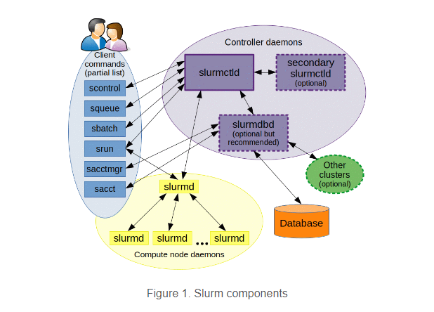

# yum -y install ohpc-slurm-server

# yum -y install slurm-sview-ohpc slurm-torque-ohpc

# vi /etc/slurm/slurm.conf

edit -> ClusterName=pearl

-> ControlMachine=master

-> NodeName=node[1-2]

# export CHROOT=/opt/ohpc/admin/images/centos7.7

# wwmkchroot centos-7 $CHROOT

# chroot ${CHROOT} uname -r

# yum -y --installroot=${CHROOT} install \

ohpc-base-compute kernel kernel-headers kernel-devel kernel-tools parted \

xfsprogs python-devel yum htop ipmitool glibc* perl perl-CPAN perl-CPAN \

sysstat gcc make xauth firefox squashfs-tools

**Slurm Configuration**

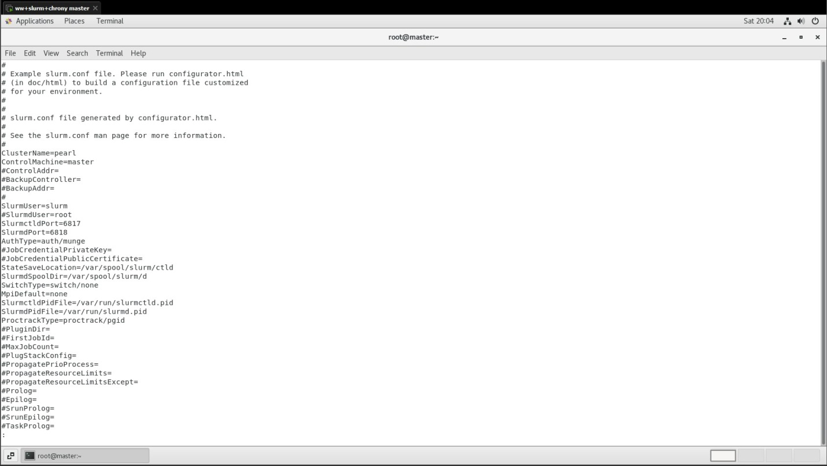

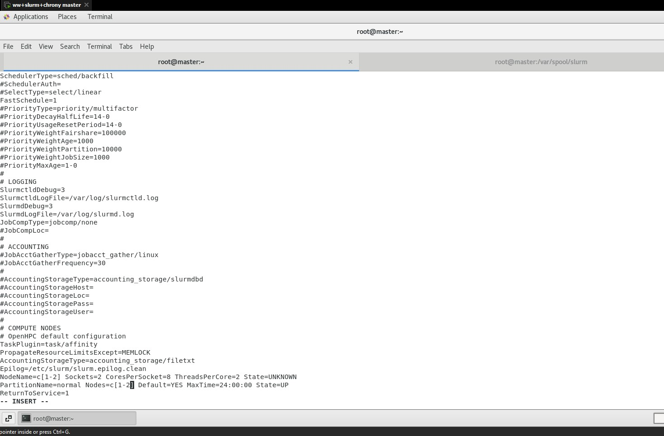

# systemctl ststus slurmctld

Slurm status on master

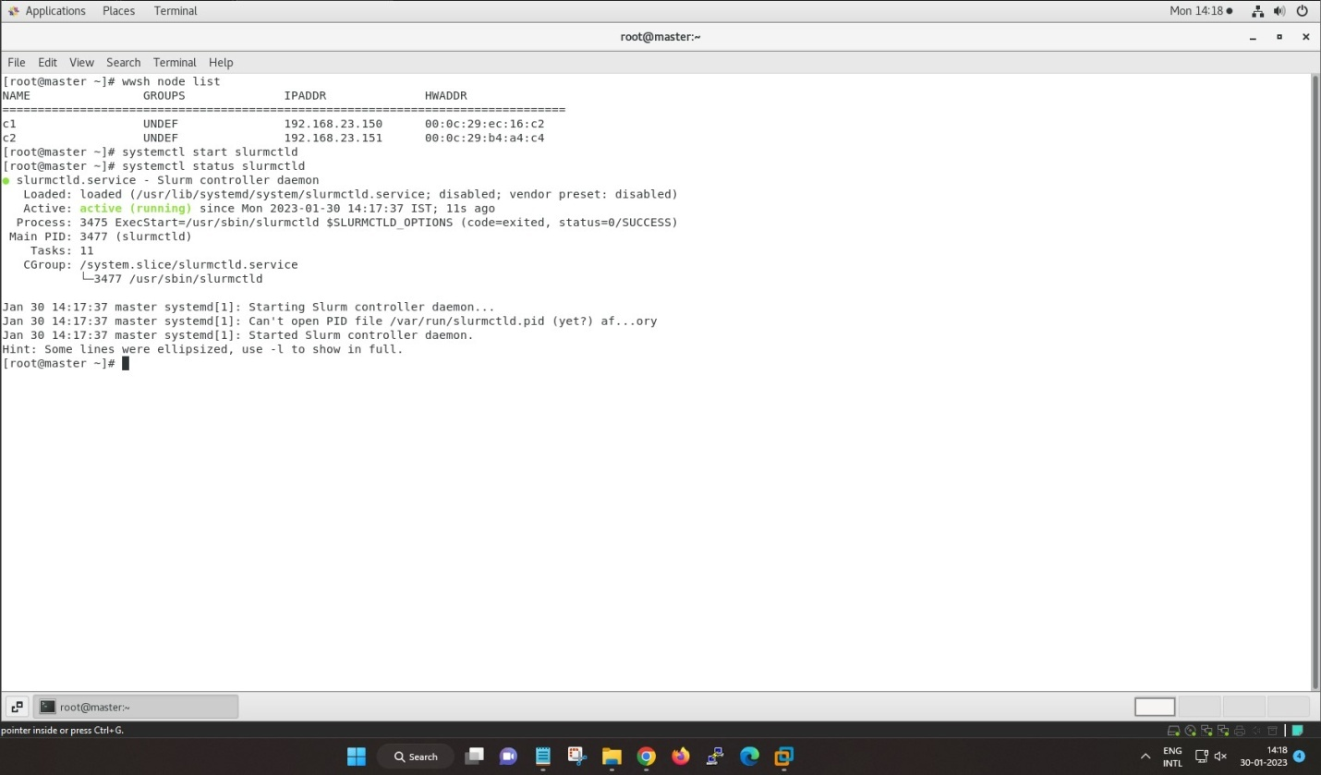

# systemctl status slurmd

Slurm status on node

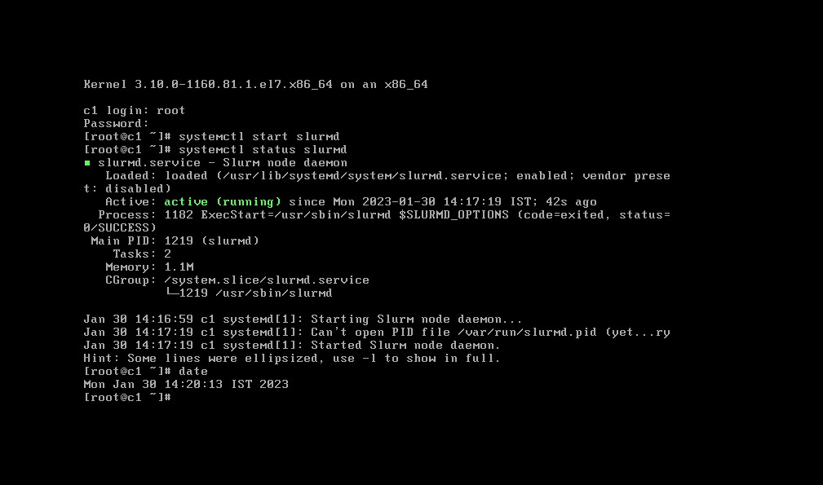

**NAGIOS**

Nagios is **an open source monitoring system for computer systems**. It was designed to run on the Linux operating system and can monitor devices running Linux, Windows and Unix operating systems (OSes). Nagios software runs periodic checks on critical parameters of application, network and server resources.

# yum -y install ohpc-nagios -> Install Nagios meta-package on master host

# yum -y --installroot=$CHROOT install nagios-plugins-all-ohpc nrpe-ohpc

# vi $CHROOT/etc/nagios/nrpe.cfg

# vi $CHROOT/etc/hosts.allow

Nagios Packages:

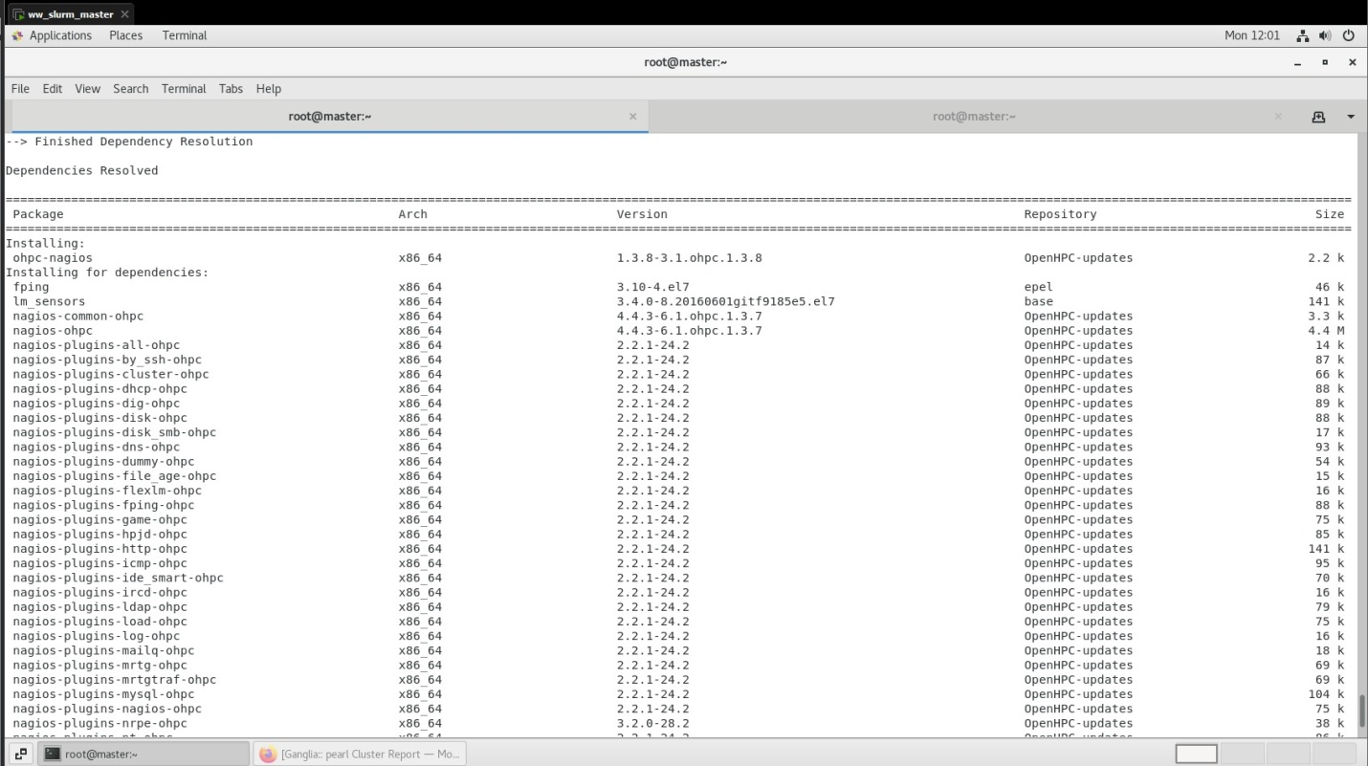

**Nagios Configuration file:**

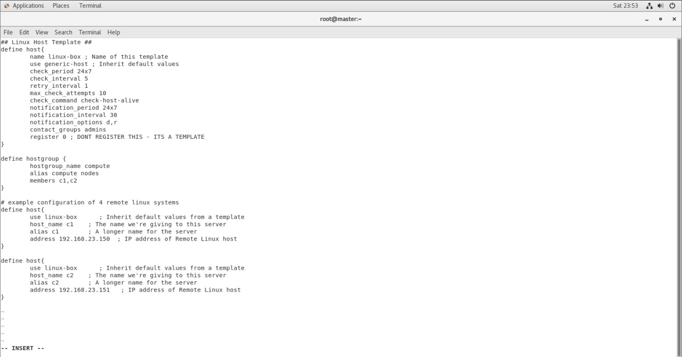

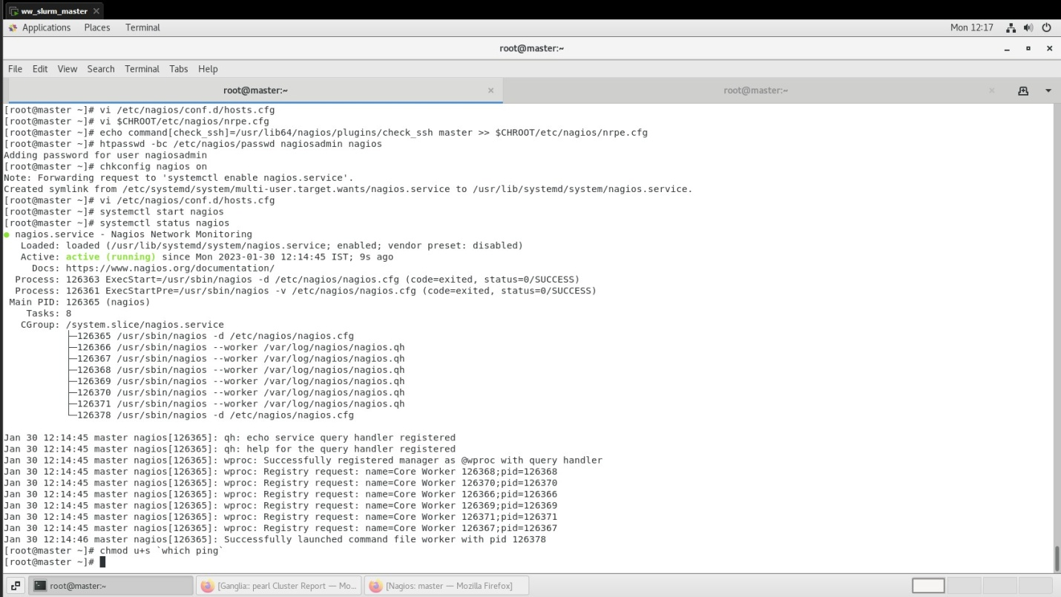

Nagios result on browser:

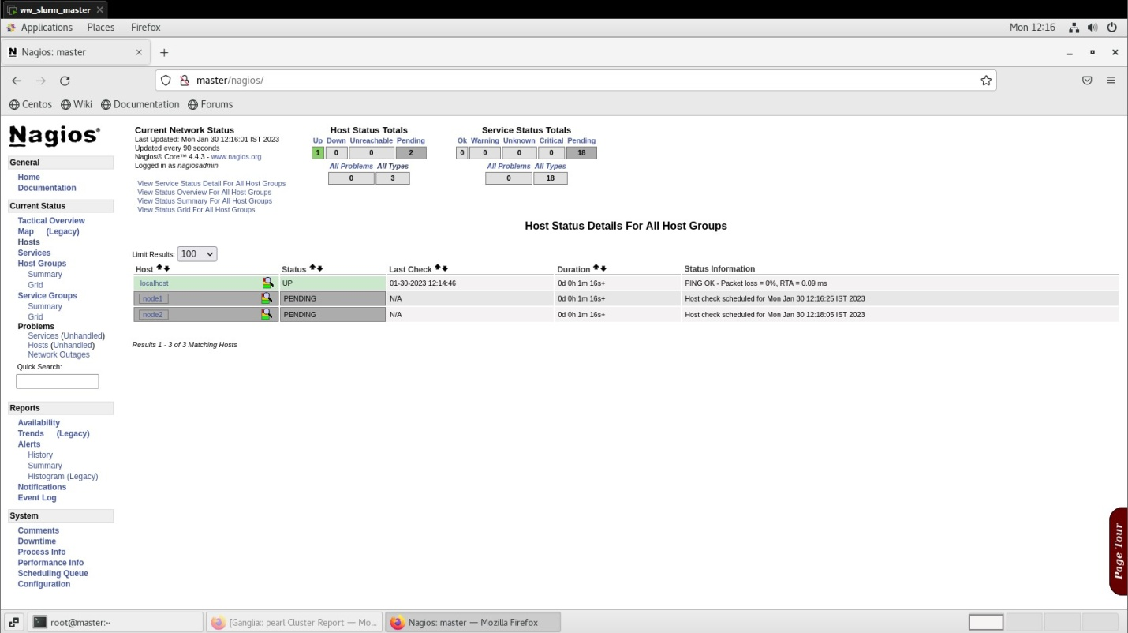

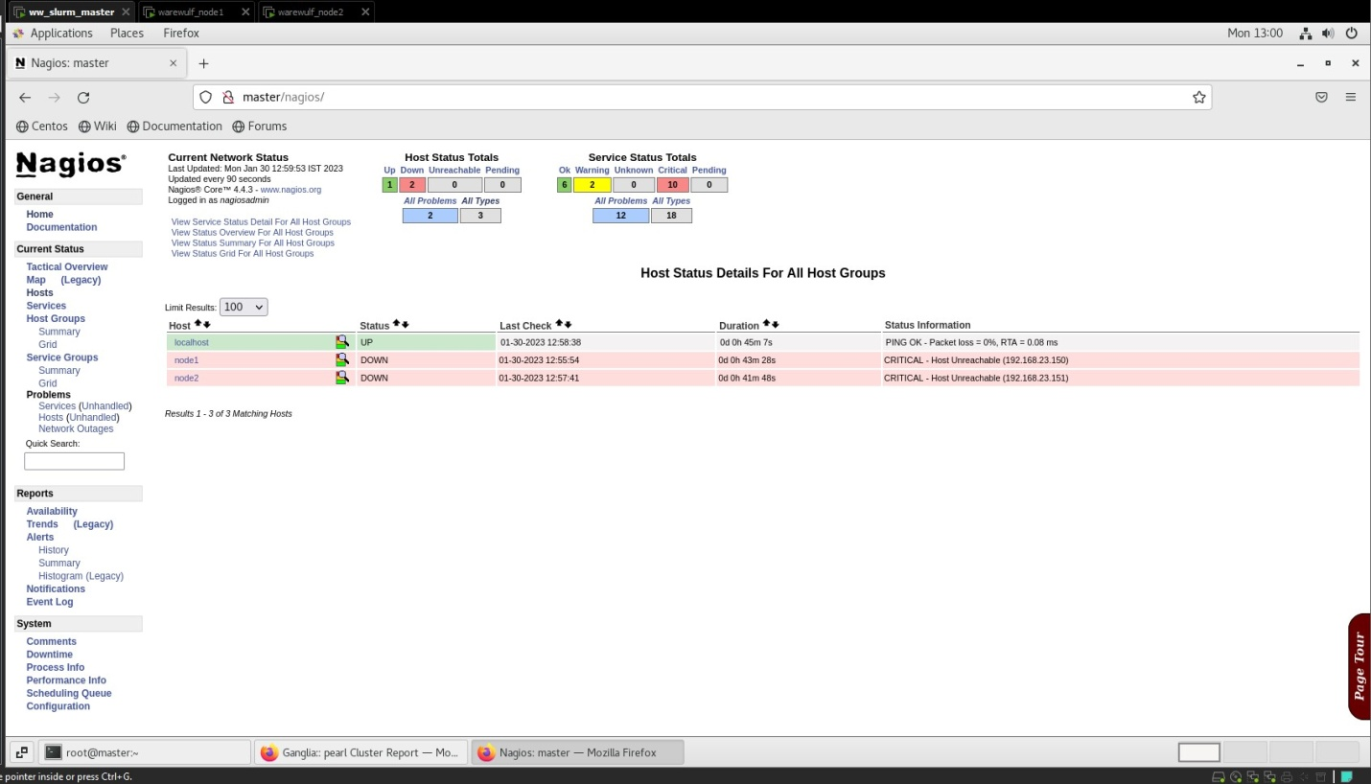

Node1 & Node2 showed

**GANGLIA**

Ganglia is **an open-source scalable distributed monitoring system for high-performance computing systems such as clusters and Grids**. It is carefully engineered to achieve very low per-node overheads and high concurrency.

# yum -y install ohpc-ganglia

# yum -y --installroot=${CHROOT} install ganglia-gmond-ohpc

# cp /opt/ohpc/pub/examples/ganglia/gmond.conf /etc/ganglia/gmond.conf

# sed -i "s/<sms>/master/" /etc/ganglia/gmond.conf

# sed -i "s/OpenHPC/pearl/" /etc/ganglia/gmond.conf

# cp /etc/ganglia/gmond.conf $CHROOT/etc/ganglia/gmond.conf

# echo "gridname pearl" >> /etc/ganglia/gmetad.conf

# echo "

systemctl enable gmond

systemctl enable gmetad

systemctl start gmond

systemctl start gmetad

chroot ${CHROOT} systemctl enable gmond

" > /tmp/start_ganglia_service.sh

# bash /tmp/start_ganglia_service.sh

# grep "^date.timezone =" /etc/php.ini

# echo "date.timezone = Asia/Kolkata" >> /etc/php.ini

# grep "^date.timezone =" /etc/php.ini

# systemctl try-restart httpd

**Go to browser :** [**http://master/ganglia**](http://master/ganglia)

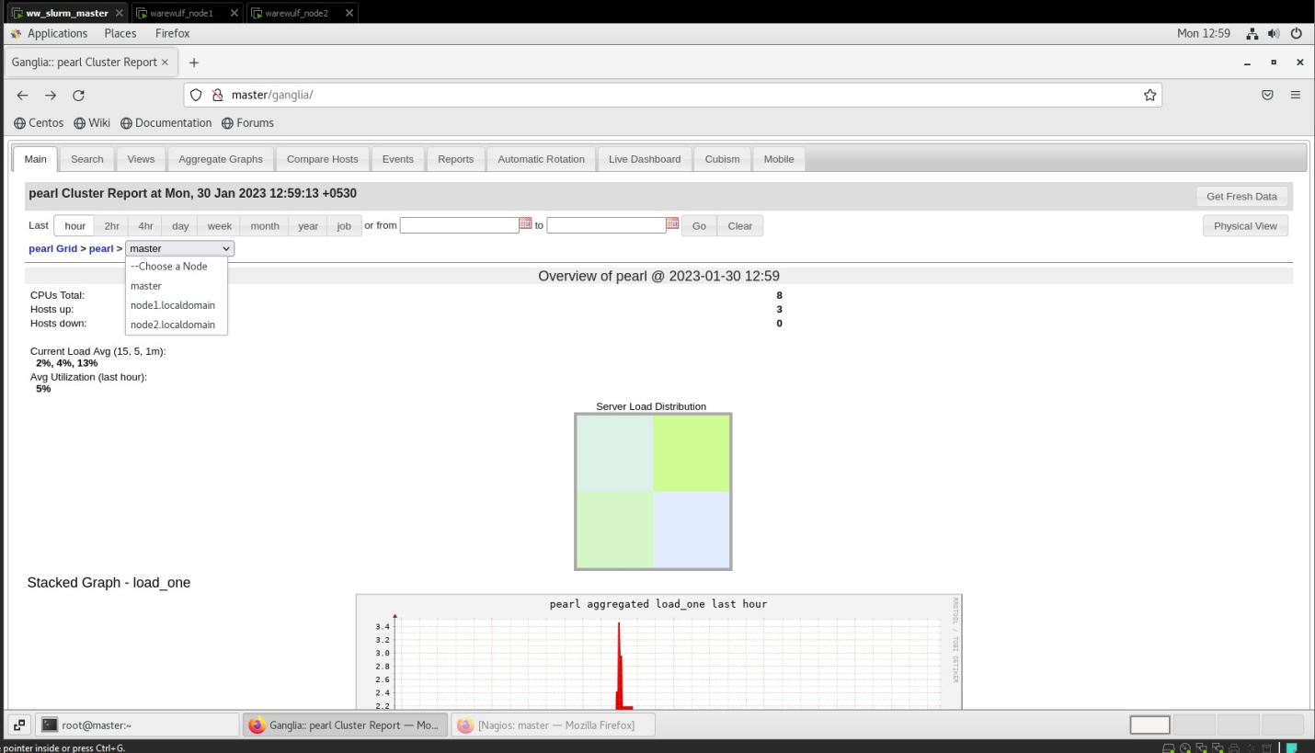

**HPL Benchmarking**

HPL is **a High-Performance Linpack benchmark implementation**. The code solves a uniformely random system of linear equations and reports time and floating-point execution rate using a standard formula for operation count.

# yum install atlas -y

# wget https://netlib.org/benchmark/hpl/hpl-2.3.tar.gz

# wget <https://download.open-mpi.org/release/open-mpi/v4.1/openmpi-4.1.4.tar.gz>

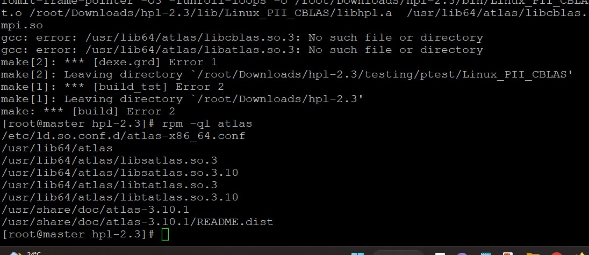

# vim Make.Linux_PII_CBLAS

>> edit # ----------------------------------------------------------------------

# - HPL Directory Structure / HPL library -------------------------

# ---------------------------------------------------------------------

TOPdir = /root/Downloads/hpl-2.

# ----------------------------------------------------------------------

# - Message Passing library (MPI) ----------------------------------

# ---------------------------------------------------------------------

MPdir = /opt/openmpi-4.1.

MPlib = $(MPdir)/lib/libmpi.so

# ----------------------------------------------------------------------

# - Compilers / linkers - Optimization flags -----------

# ----------------------------------------------------------------------

# CC = /usr/bin/gcc

LINKER = /usr/bin/gcc

# ----------------------------------------------------------------------

# - Linear Algebra library (BLAS or VSIPL) ---------------------

# ----------------------------------------------------------------------

LAlib = $(LAdir)/libsatlas.so.3 $(LAdir)/libtatlas.so.3

>> <Escape Key> : wq

# cd /root/Downloads/hpl-2.3/bin/Linux_PII_CBLAS/

# vi HPL.dat

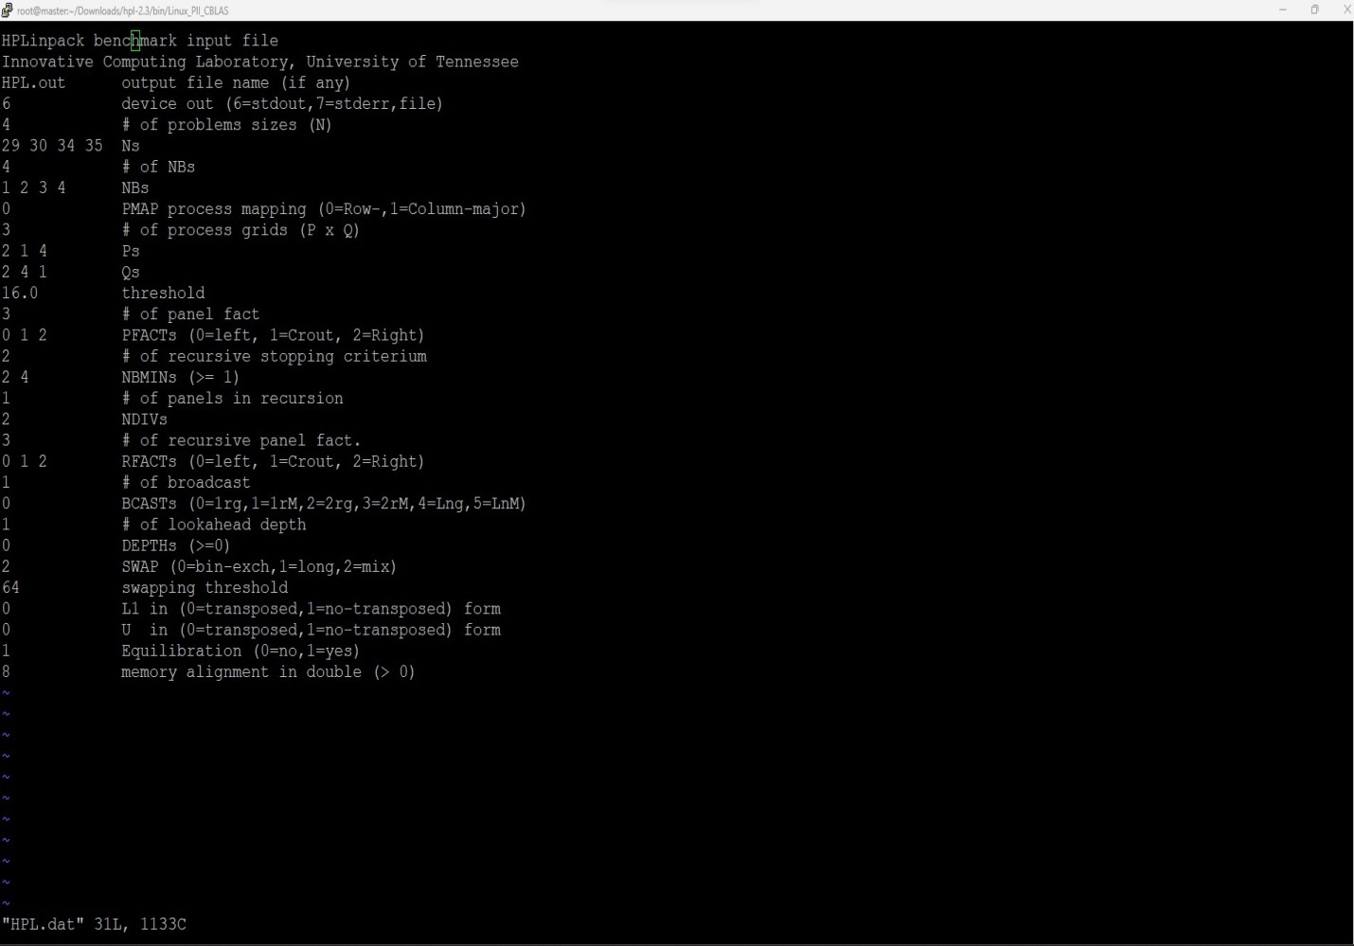

# mpirun --allow-run-as-root -np 4 ./xhpl HPL.dat

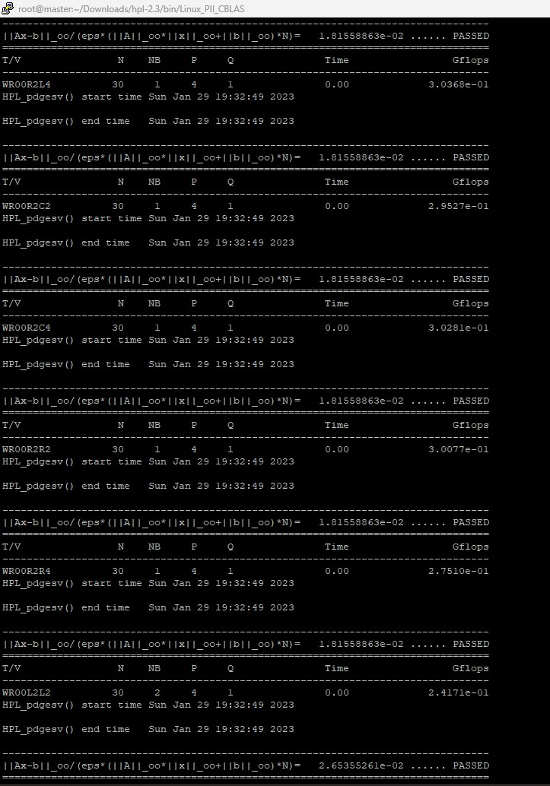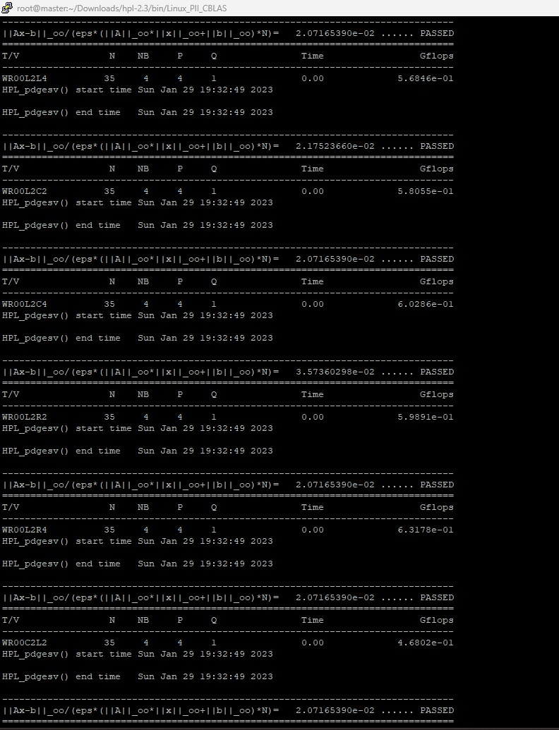

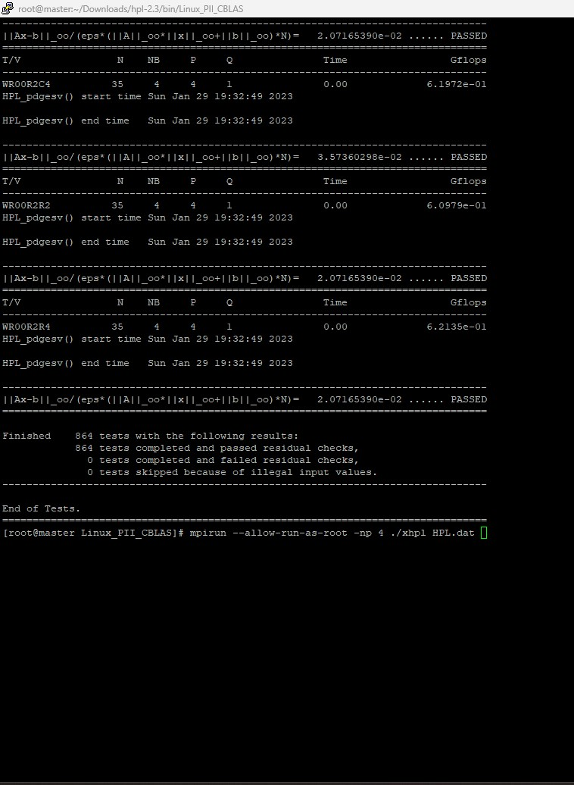

**Cammands History**

Work-Flow Commands:

**Configuring Warewulf, Slurm, Nagios, Ganglia**

**Link1:** [**ohpc-warewulf-slurm-nagios-ganglia.txt**](ohpc-warewulf-slurm-nagios-ganglia.txt)

**Configuring HPL Benchmarking**

**Link2:** [**hpl benchmarking.txt**](hpl%20benchmarking.txt)